Subject Area | Week 1 | Week 2 | Week 3 | Week 4 | Week 5 | Week 6
English | Myth Atlas – Thiago de Moraes | Myth Atlas – Thiago de Moraes | Myth Atlas – Thiago de Moraes | Everest - Sangma Francis and Lisk Feng | Everest - Sangma Francis and Lisk Feng | Everest - Sangma Francis and Lisk Feng
Mathematics | Number: Fractions | Number: Fractions | Number: Fractions | Number: Decimals | Number: Decimals | Number: Decimals
Science  Working scientifically | Animals Including Humans  Research from secondary sources | Animals Including Humans  Pattern seeking | Animals Including Humans  Pattern seeking | Animals Including Humans  Fair testing | Animals Including Humans  Pattern seeking | Animals Including Humans  Fair testing
Computing | Logo | Logo | Logo | Animation | Animation | Animation
PE  Indoor  Outdoor | Dance  Cricket | Dance  Cricket | Dance  Cricket | Dance  Cricket | Dance  Cricket | Dance  Cricket
History | Ancient Egypt | Ancient Egypt | Ancient Egypt | Ancient Egypt | Ancient Egypt | Ancient Egypt
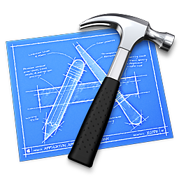  RE | Salvation - Why do Christians call the day that Jesus died ‘Good Friday’? | Salvation - Why do Christians call the day that Jesus died ‘Good Friday’? | Salvation - Why do Christians call the day that Jesus died ‘Good Friday’? | Salvation - Why do Christians call the day that Jesus died ‘Good Friday’? | Salvation - Why do Christians call the day that Jesus died ‘Good Friday’? | Salvation - Why do Christians call the day that Jesus died ‘Good Friday’?
PSHE | How Will We Change and Grow? | How Will We Change and Grow? | How Will We Change and Grow? | How Will We Change and Grow? | How Will We Change and Grow? | How Will We Change and Grow?
MFL | How I Get to School | How I Get to School | Describe Places in School | Describe Places in School | What Subjects I Like | What Subjects I Like
Music | Lean on Me | Lean on Me | Lean on Me | Lean on Me | Lean on Me | Lean on Me
Art | Paul Klee | Paul Klee | Paul Klee | Vincent Van Gogh | Vincent Van Gogh | Vincent Van Gogh

