Welcome to Year One!

Welcome to 1CP! We are so excited to hear that you are going to be in our class. It is going to be a great year full of friends, games, new adventures and new challenges.

Meet the Teachers!

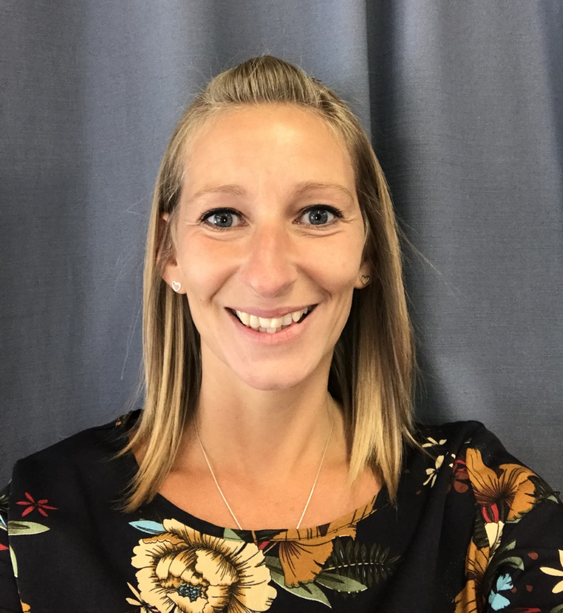

I am Mrs Cusack and I teach on Mondays, Tuesday and Wednesdays. I have two young girls so on the days that I’m not with you, I am looking after them.

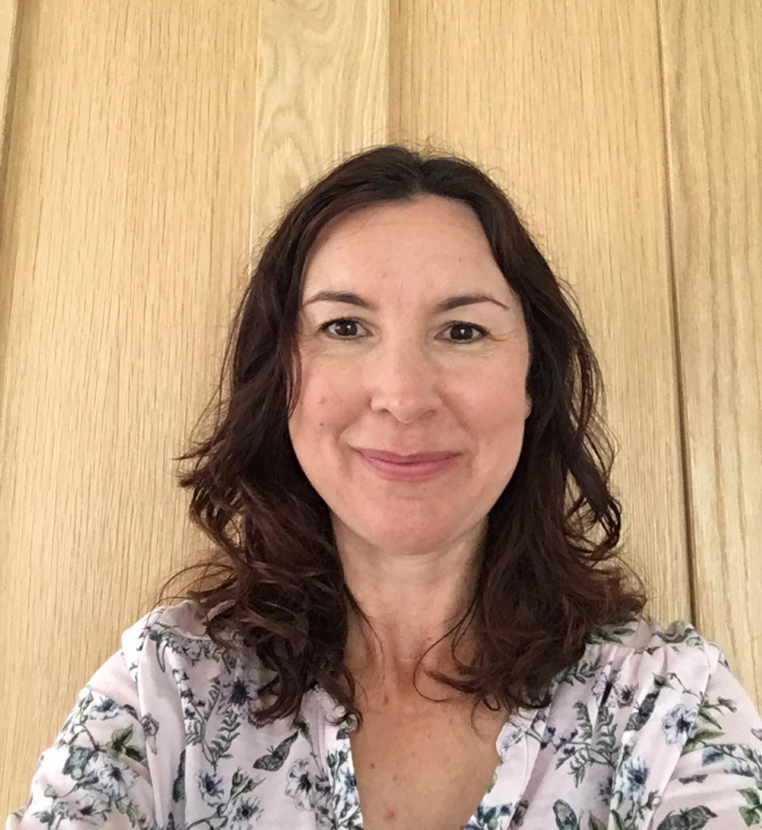

I am Mrs Pring and I teach on Thursdays and Fridays.

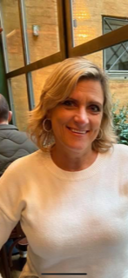

We also have Mrs Perryman who is in class with us every morning!

We can’t wait to get to know you. We are going to have a great year together!

See you soon!

